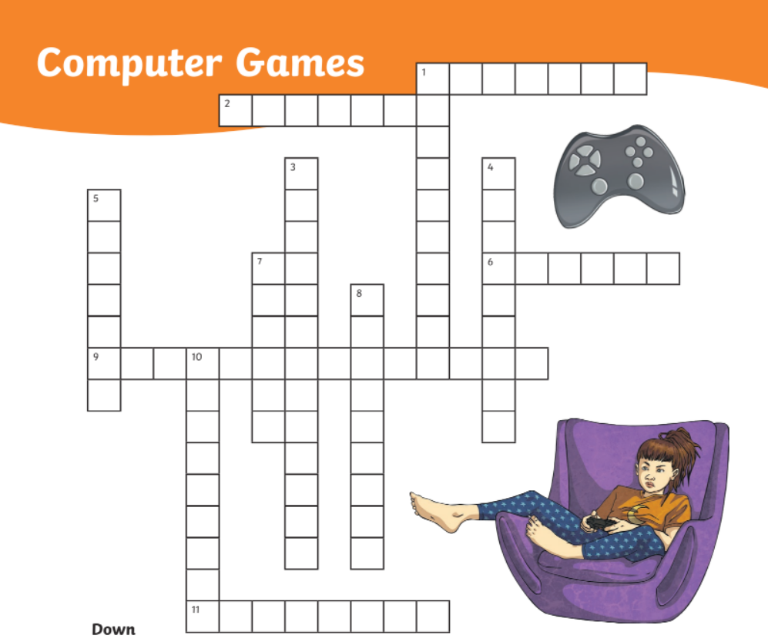

5

3

8
1 - Fire some mad birds at green pigs. (DOWN)
1 - Use your brain to catch the imposter.
2 - Catch, train and fight cute and powerful monsters.
3 - Watch a concert, build an island or fight.
4 - Show your dancing moves.
5 - Dig for diamonds, build houses and run from creepers.
6 - Move different blocks down and make them vanish.
7 - Make your own game and play with others.
8 - Running game in Mushroom Kingdom.

1-angrybirds/amongus
2-pokemon
3-fortnite
4-justdance
5-minecraft
6-tetris
7-roblox
8-mario

